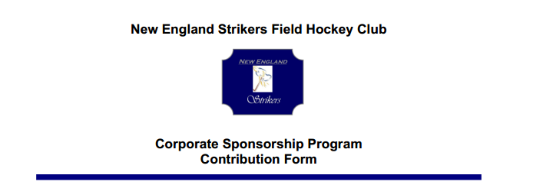
Sponsor/Business Name:
Address:
City: | State: | Zip:
Phone #
Email address:
Contact Name:
* Name/ Website:
* *Please list name and/or website to be placed on banner and The New England Strikers
website. A New England Striker representative will contact you to obtain a copy of your
logo for placement on the website and banner.

The New England Strikers Field Hockey Club is a qualified 501(c)(3) tax-exempt organization and
your contribution is tax deductible for federal income tax purposes.

Contribution
- $200 (Bronze) | - $300 (Silver) | - $500 (Gold) | $750+ (Platinum)
- Check enclosed (payable to The New England Strikers Field Hockey Club)

Send your completed contribution form to:

Linda Friend, Director
New England Strikers Field Hockey Club
PO Box 383
N. Easton, MA 02356
Once your donation is received, you will be provided with a letter from the New England Strikers
detailing your contribution for tax purposes.

Thank you for your support of The New England Strikers Field Hockey Club

